227 IEC 08(RV-90)
3C認証電線

CCCNr:2002010105026699
Non-sheathed cables for fixed Wiring 90℃ 300V/500V PVC無護套電線
● 導體使用鍍錫或裸銅絞線, 並符合GB/T3956。  ● 導體之規定第5種導體要求。  ● 使用環保PVC絕緣。  ● 額定溫度：90℃,額定電壓：300V/500V.  ● 可通過GB12666垂直型耐燃測試。 | Product Description  ● Solid is tinned copper, bare copper, accord with.  ● The standard of GB/T3956, Class 5 .  ● Lead Free PVC Insulation.  ● Rated temperature:90℃;Rated voltage: 300V/500V.  ● Passes GB12666Vertical Flame Test.

● 一般電子, 電器設備內部配線. | Applications  ● For internal wiring of electronic and electrical Equipment.
構造及電氣性能(Structure & electrical properties)

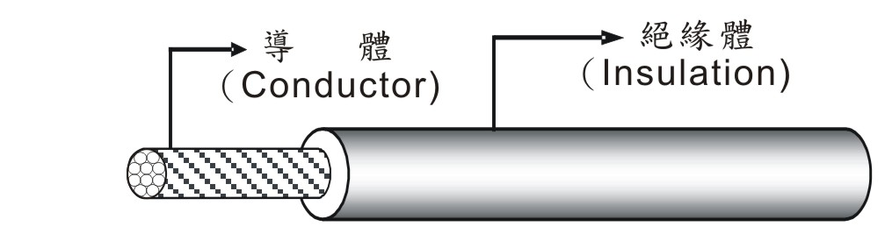

產品  類別 Product Type | 標稱截面積 Section  Area  mm² | 構造 Construction (No/mm) | 絕緣體  Insulation |  | 最大導體  電 阻 Maximum Conductor ResistanceΩ/km | 70℃時  最小絕緣阻 抗 Minimum Insulation Resistance MΩ/km | 絕緣耐  電壓 (VAC/min) Insulation Potential Strength
產品  類別 Product Type | 標稱截面積 Section  Area  mm² | 構造 Construction (No/mm) | 厚度Thickness mm | 外徑  O.D.  mm | 最大導體  電 阻 Maximum Conductor ResistanceΩ/km | 70℃時  最小絕緣阻 抗 Minimum Insulation Resistance MΩ/km | 絕緣耐  電壓 (VAC/min) Insulation Potential Strength
227 IEC 08 (RV-90) | 0.50 | 20/0.180 | 0.60 | 2.20 | 40.1 | 0.013 | 2000
227 IEC 08 (RV-90) | 0.50 | 16/0.200 | 0.60 | 2.20 | 40.1 | 0.013 | 2000
227 IEC 08 (RV-90) | 0.75 | 30/0.180 | 0.60 | 2.40 | 26.7 | 0.011 | 2000
227 IEC 08 (RV-90) | 0.75 | 24/0.200 | 0.60 | 2.40 | 26.7 | 0.011 | 2000
227 IEC 08 (RV-90) | 1.00 | 41/0.180 | 0.60 | 2.60 | 20.0 | 0.010 | 2000
227 IEC 08 (RV-90) | 1.00 | 32/0.200 | 0.60 | 2.60 | 20.0 | 0.010 | 2000
227 IEC 08 (RV-90) | 1.50 | 30/0.254 | 0.70 | 3.00 | 13.7 | 0.009 | 2000
227 IEC 08 (RV-90) | 1.50 | 48/0.200 | 0.70 | 3.00 | 13.7 | 0.009 | 2000
227 IEC 08 (RV-90) | 2.50 | 50/0.254 | 0.80 | 3.80 | 8.21 | 0.009 | 2000
227 IEC 08 (RV-90) | 2.50 | 80/0.200 | 0.80 | 3.80 | 8.21 | 0.009 | 2000

